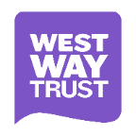
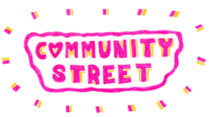
Westway Community Street Project Group

Expression of Interest Form for Community Members

If you have any queries, would like to find out more about what this role will involve, please don’t hesitate to email Wioletta Campbell; Community Street Project Manager at wioletta.campbell@westway.org

If you would like to apply, please complete this form and return it to: communitystreet@westway.org by 5pm August 31th 2021

Your contact details
- Name
- Postal address
- Postcode
- Email address
- Phone number
- What interests you in being a member of the Westway Community Street Project Group? (200 words max)

- Tell us how your knowledge, skills and experience will contribute to the oversight of the delivery of the Westway Community Street project. (200 words max)

- Any other comments you wish to make in support of this application.

- We would like to offer remuneration of £50 per meeting for any community member who is chosen to be on the Project Group.
Would you like to receive remuneration?

